Valleys of Neptune

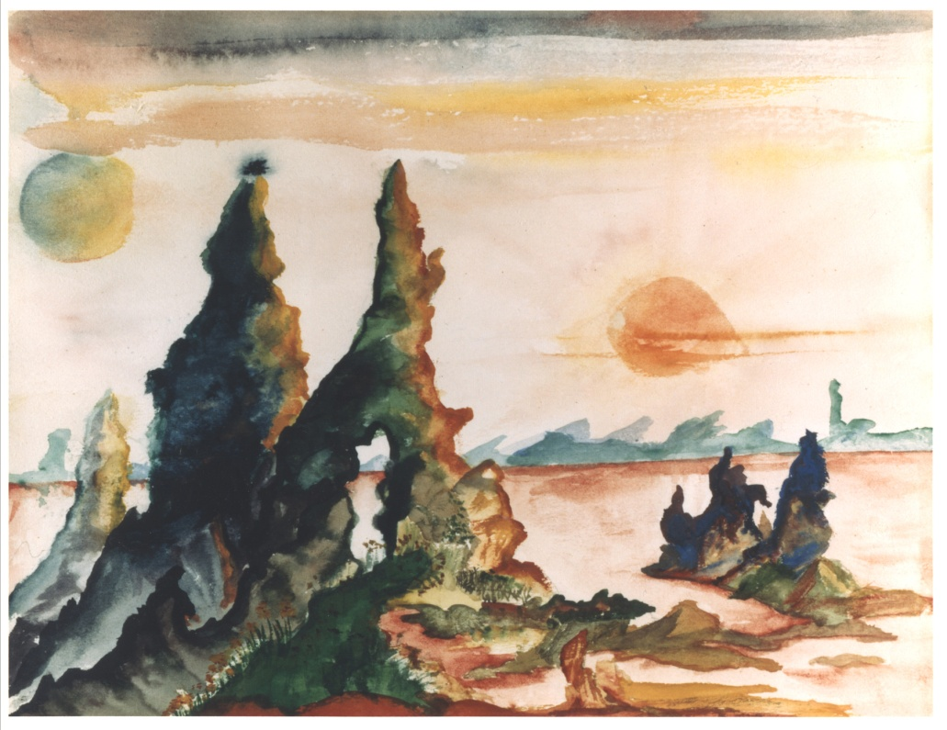
Aside from his songwriting and legendary guitar playing, Jimi Hendrix was known for his visuals, whether it be trippy album covers or his acrobatic, intense stage presence. Now, with the cover art and video for his new single, 'Valleys of Neptune,' we get a glimpse into Jimi's ability as a painter as well.
According to Experience Hendrix CEO Janie Hendrix, her brother originally wanted to be an artist. "He went through a phase doing watercolors at school and this was one of the 110 drawings of his that our father kept," she tells Spinner. "When I saw this one from 1957, it screamed 'Valleys of Neptune' so we just knew we'd use it for this project."
That painting is used as a motif throughout the video -- produced by String Theory Design -- for 'Valleys of Neptune,' the title track of an upcoming album, due March 9, of studio tracks Hendrix recorded in 1969. The songs capture Jimi's transition from the Experience, the group that originally made him famous, to his later work, which was cut short by his death in 1970.

View the Valleys of Neptune video at AOL's Spinner

